Authors' Responses to Comments for TEVC-00117-2024
Dear Editors and Reviewers:
First of all, we would like to express sincere gratitude to for your time in handling and reviewing our paper and all the constructive comments. The comments have significantly helped us improve the quality and presentation of this paper. We have now carefully revised the manuscript according to them. In the following, the responses to them are highlighted using blue-colored text.

Reviewer: 1
In the manuscript, a search space reconstruction-based evolution algorithm is designed for optimization. The topic is interesting and worthy of investigation. Experiments and comparison studies also demonstrate the effectiveness of the proposed method. However, there are several issues that should be further addressed.
Response: Thanks very much for your time and efforts to review this manuscript. And thanks very much for your positive comment, we really appreciate your valuable suggestions. We have carefully addressed all the comments and suggestions when preparing the revision of this manuscript.

Comment 1: The effectiveness of search space reconstruction methods depends on the quantity and quality of training samples. If the training samples do not include sufficiently good solutions to the problem, then the learned search space may not be representative. For example, if the optimal solution to an optimization problem is 1, but the best solutions in the training samples are all above 10, then the value of the learned search space might be limited. How can one determine if the quantity and quality of training samples are sufficient to ensure that the learned reconstructed search space is sufficiently representative? Authors may further discuss this issue.
Response: Thank you very much for your insightful questions. The quantity and quality of training data indeed play a crucial role in the effectiveness of search space reconstruction methods. We address this issue from the following two aspects:
1)Algorithm Exploration and Fitting Strategy
Our approach focuses on fitting the exploration path of the algorithm. In the scenario you mentioned, where all the optimal solutions in the training samples are above 10, the network can only learn this part of the space, trying to identify those that are most likely to eventually optimize to 1. Therefore, enhancing the ability to explore the search space broadly is essential. This is why we use the univariate marginal distribution algorithm for continuous domains (UMDAc) as the initial exploration tool. The UMDAc algorithm assumes minimal interactions between variables, it can explore the search space more thoroughly.
In Section Ⅲ-C, we have now provided additional details on the Univariate Marginal Distribution Algorithm continuous (UMDAc) and its application as an exploration operator.
2)Ensuring the Quality and Quantity of Training Samples
Regarding the quantity of samples, the number of training samples in our algorithm is controlled by the number of sampling iterations (T) of the UMDAc algorithm. Theoretically, increasing the number of samples deepens the understanding of the search space; the larger the value of T, the more training samples there are, and the better the network performs. However, due to the limited number of evaluations, excessive consumption of evaluations in the exploration phase can result in insufficient evaluations for the subsequent exploitation. Therefore, a careful balance of the T value is needed. We discuss the sampling iteration count (T) in Table Ⅳ. It shows that when other network training parameters are set the same, the algorithm performs best when T is set to 100. Too few sampling times make it difficult for the network to learn, while too many sampling times can affect the subsequent development of the algorithm.
Regarding the quality of samples, we indirectly ensure the quality of training samples by measuring the ratio of exploitation to exploration of the population. When T is 100, the number of evaluations consumed is 20000. As shown in Fig. 4, the population is basically stable at this point and is overall in an exploitation state, indicating that the algorithm has largely completed the exploration process. This ensures the quality of our training samples.
We have also provided additional explanations in Section Ⅳ and specifically in the last two paragraphs of Section Ⅳ-E, respectively.

Comment 2: Essentially, the deep learning-based search space reconstruction method is a one-to-many learning problem. This problem is not easy, especially when D=100, which means transforming 1-dimensional training data into 100-dimensional results, making it even more challenging. However, in practical applications, the neural networks used in the paper are not very deep, which makes this problem seem relatively easy. It is recommended that the authors discuss and clarify this issue.
Response: Thank you very much for your constructive suggestions.
The proposed DLES, leverages neural networks' non-linear fitting capabilities to reconstruct exploration paths—sequences of sampled points generated during the search process. Although it explores the solution space extensively, the exploration paths themselves are relatively small compared to the entire solution space. This allows us to achieve effective reconstruction using simpler networks, as the scope of the paths is much smaller than the full solution space. We have now provided additional explanations in Section III-A.
Besides, we also recognize that as the dimensionality D increases, using deeper and more complex networks may yield better results. Based on your suggestion, we have now added a performance comparison using networks of varying depths across different dimensions in Section Ⅲ of the Supplementary File. In this comparison, "No-Net" indicates no neural network is used for search space reconstruction, while "Net1" to "Net5" represent networks with increasing depth and width. We utilize the Friedman rank sum test to calculate the scores of each network across different dimensions, and the results are presented in Supplementary File’s Table S.IV.
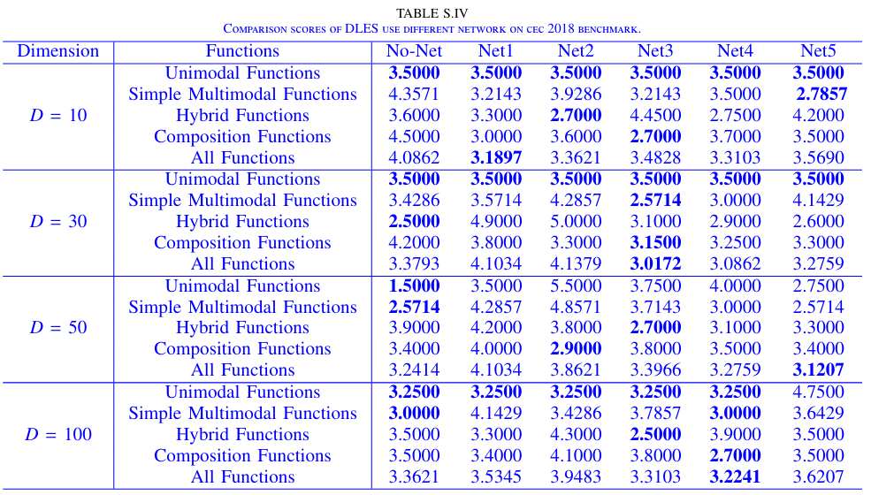
From the perspective of problem complexity, there does not appear to be a clear correlation between the complexity of the network and the difficulty of the problem. From a dimensionality perspective, when D is within the range of 10 to 50, more complex networks tend to achieve better performance as the dimensionality increases. However, when D = 100, this trend is disrupted; the performance of the more complex network (Net5) is inferior to that of the simpler networks (Net1, Net3, and Net4). We speculate that this could be due to the following reasons:
- The deep networks we used are simple MLPs, which may not be the most suitable architecture for this type of problem. Exploring other advanced deep networks, such as transformers, or designing a more fitting network architecture might yield better results. This is one of the directions we plan to explore next.
- As the depth of the network increases, the amount of data required for training also increases significantly. Under the current limitations of sampling times, it is challenging to provide sufficient data for deeper networks to learn effectively, which may have led to the observed performance degradation with more complex networks.
Generally, selecting the most suitable network for different problems is more effective. However, this approach would result in an algorithm tailored to specific problems, which contradicts the objective of our research. Therefore, we choose Net3, which maintains good performance across most scenarios, as our base network.

Comment 3: The design of the loss function (Equation 7) for the search space reconstruction method is reasonable, but there may be risks due to the discrepancy in units between the two parts of the loss function. For example, suppose the optimal solution is 10000, while the search space is limited to within 10. In this case, even if the reconstruction loss is significant, it may still be negligible relative to the optimal solution. Consequently, the search space reconstruction method may devolve into merely a search method, losing its original research intent. It is suggested that the authors further discuss this issue.
Response: Thank you very much for your suggestion which highlights this important issue. We apologize for the previous oversight in our manuscript, where the formula was not clearly presented regarding the handling of $f_{i}$. We have since corrected this issue to provide a clearer and more accurate representation. Indeed, the discrepancy in units between the two parts of the loss function could potentially lead to the algorithm degrading into merely a search method. We recognize the significance of this concern and have revised the loss function accordingly. Therefore, we have now modified Eq. (7).
Firstly, we standardize the value of $f_{i}$ by converting it to a normal distribution, and then, to further ensure that both parts of the loss function have the same units, we scale it by multiplying by D. This adjustment helps to mitigate the differences in scale between the two components of the loss function. We have also added the explanations regarding these modifications after Eq. (7).

Reviewer: 2
This manuscript introduces a Deep Learning-based Search Space Reconstruction Evolution Strategy (DLES) to enhance the performance of evolutionary algorithms in high-dimensional search spaces. Traditional evolutionary algorithms encounter challenges in fully exploring these spaces due to their complexity. DLES addresses this by using a fully connected neural network to reconstruct the search space based on discrete data sampled during the exploration process. This enables the algorithm to transform discrete sampled information into a continuous form, facilitating comprehensive exploration. Experimental validation on multiple datasets, including CEC 2014, CEC 2018, and CEC 2022, demonstrates the superiority of DLES over other powerful algorithms in identifying superior solutions.
Response: Thanks very much for your time and efforts to review this manuscript, and we really appreciate your valuable suggestions. We have carefully addressed all the comments and suggestions when preparing the revision of this manuscript.

Comment 1: Why did the authors use an evolutionary strategy rather than a traditional population-based evolutionary algorithm? Related work lacks research on evolutionary algorithms.
Response: Thank you very much for your constructive comment.
Evolution Strategies (ES) utilize mutation operators that typically depend on an individual’s own standard deviation, allowing the algorithm to adaptively adjust the search step size. ES focuses on mutation and selection without relying on crossover operations, which contributes to a more stable optimization process, particularly when addressing multimodal or high-dimensional problems. Since ES does not depend on population reconstruction, it is less sensitive to the choice of the initial population and exhibits strong robustness. Even if the quality of the initial solutions is poor, the algorithm can still gradually converge to high-quality solutions. The design of ES is inherently suited for continuous optimization problems in high-dimensional spaces, especially those involving noise, non-linearity, or multiple optima. Based on these advantages, we chose to explore the solution space using ES as our foundational evolutionary computation (EC) method without introducing other complex mechanisms. We have now added additional explanations in the last paragraph of Section Ⅱ-B.
We apologize for the lack of related research on evolutionary algorithms in the previous version. We have now included additional relevant work on evolutionary algorithms in Section Ⅱ-A. Evolutionary Computation.

Comment 2: How to ensure that after inputting 1-dimensional data, the proposed three-layer neural network model can accurately predict D-dimensional individual information and still be more effective in higher dimensions. This is not quite common sense. The validation of the mapping accuracy of the network in different dimensions is not reflected in the manuscript ?
Response: Thank you very much for your insightful question.
The effectiveness of our three-layer neural network in predicting D-dimensional individual information, is attributed to two factors.
1.Training data quality and quantity: We ensure that our training dataset is both abundant and of high quality. This comprehensive dataset enables the network to learn meaningful patterns and relationships that are representative of higher-dimensional spaces. We address how to ensure the quantity and quality of the data in detail in our response to your sixth question.
2.Loss Function: We design a specific loss function tailored to improve the network’s learning and fitting capabilities. This loss function aids the network in effectively capturing the complexities of the data, even as the dimensionality increases.
Based on your feedback, we also recognize that using more complex networks may offer better performance as dimensionality increases. To explore this, we have now conducted additional experiments with networks of varying complexities across different dimensions and problem difficulties. The results are shown in the Supplementary File’s Table S.IV.

As the dimensionality and complexity of the problem increase, more complex networks tend to perform better. However, it's important to note that increased complexity does not always translate to improved performance. For instance, at D = 100, the performance of the most complex network significantly deteriorates. We hypothesize that this is due to the increased training difficulty associated with deeper and wider networks, which exponentially increases the resources required for training. The limitations on the number of evaluations and the quality of training samples in our current setup may not suffice to meet the needs of highly complex networks. Selecting the most suitable network for different problems is more effective. However, this approach would result in an algorithm tailored to specific problems, which contradicts the objective of our research. Consequently, we opt for the Net 3 architecture as a balanced choice.
Our network is designed to fit the exploration paths within the solution space, identifying solutions with higher potential for further development. These exploration paths are formed by the historical sampling points left by the algorithm during its exploration of the solution space. Therefore, the network is not tasked with fitting the entire solution space, which significantly reduces its computational load and allows a seemingly simple three-layer fully connected network to effectively accomplish this task. It is important to clarify that when we refer to a three-layer fully connected network, we mean a network constructed purely with fully connected layers without employing other complex network structures. This includes the input layer, hidden layers, and the output layer, where the hidden layers may consist of multiple fully connected mappings. Meanwhile, the comprehensive results also demonstrate the three-layer network’s superiority in Table IV.
By focusing on fitting the exploration paths rather than the entire solution space, our approach ensures that even a relatively straightforward network structure can achieve the necessary mapping accuracy across varying dimensions, including higher-dimensional settings.

Comment 3: Is this article a reconstruction of the solution space or a reconstruction of the objective space? It looks like a reconstruction of the objective space to search for the location of a better objective space. Where is the reconstruction for the solution space? Does it refer solely to the portion of individuals predicted based on fitness values? And what is the reconstructed search path mentioned by the authors? Rigorous formulation is recommended.
Response: Thank you for pointing out this crucial detail. We apologize for any confusion caused by our description. We will address your questions one by one:
1. Reconstruction Focus: We want to clarify that our work focuses on reconstructing the solution space. The network learns information about individuals corresponding to their fitness values. Thus, our approach involves reconstructing the solution space based on this individual information.
2. Process of Solution Space Reconstruction: The reconstruction of the solution space is indeed the process of network learning. By learning individual information, the network reconstructs the solution space. Once the network has completed its learning process, the solution space is deemed to be reconstructed.
3. Extent of Solution Space Reconstruction: The reconstruction of the solution space is not limited to individuals predicted based on fitness values alone. It encompasses a broader range of individual information that the network learns during the training process.
4. Exploration Path and Reconstructed Path: In our paper, the concept of the exploration path is crucial. The algorithm continuously samples while exploring the solution space, with each sampling operation capturing a point. As the algorithm samples multiple times, the sequence of these historical sampling points forms what we refer to as the exploration path. We use the network to reconstruct the solution space encompassing the region traversed by the path.
We have now provided additional explanations in section Ⅲ-A.
Besides, we have also included a visualization of the network’s reconstructed exploration pathin Fig.4 providing a clearer and more intuitive demonstration of our approach. The detailed analysis is given in Section IV-G.

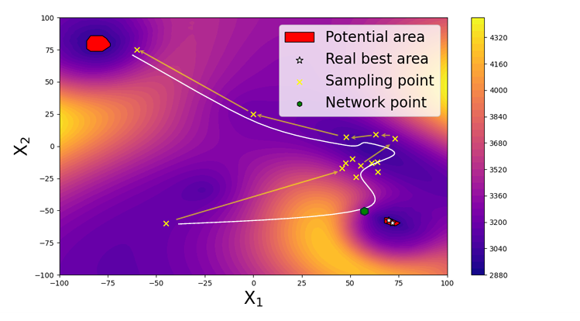
Fig. 4 Visualization of the exploration process of DLES algorithm on CEC 2018 F27.

Comment 4: Where is the complete algorithmic flow framework? What is the relationship between the three pseudo-codes in the manuscript?
Response: Thank you very much for your detailed and constructive questions. We now recognize the importance of a flowchart for understanding the overall process of the algorithm. Therefore, we have now modified Fig. 2 to clearly exhibit the structures and framework of DLES.
The three pseudocode segments in the manuscript represent the three main components of the algorithm. These components are executed sequentially, starting with the evolutionary operator for exploration, which explores the solution space and collects and processes data. Subsequently, the network reconstruction phase uses the collected data to reconstruct the solution space, providing more promising solutions for further exploration. Finally, the hybrid sampling for the exploitation phase utilizes these network-generated solutions to conduct the final optimization. Additionally, we have now renamed the pseudo-code to ensure consistency within the context. We have also included relevant descriptions in Section Ⅲ-B.
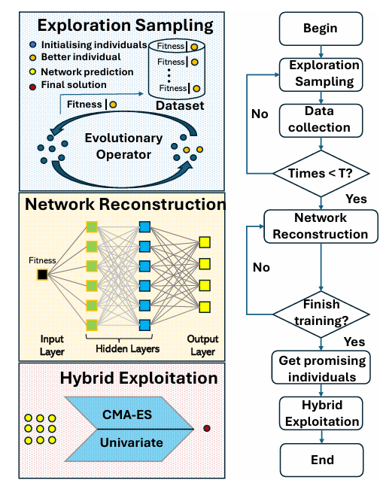
Fig. 2 The structure and flow framework of DLES.

Comment 5: The search space is large, how do you ensure that the sampled data adequately represents the original entire space.
Response: Thank you very much for raising this significant point. Given the vast search space, it is challenging to ensure that the sampled data fully represents the entire space. However, our approach does not aim to cover the entire space exhaustively. Instead, we use the UMDAc algorithm to explore, focusing on high-potential areas. UMDAc assumes minimal interactions between variables, it can explore the search space more thoroughly. We have now added the explanation and application of UMDAc in Section Ⅲ- C.
In addition, the network fits and reconstructs only a portion of the solution space, specifically along the exploration path, where we concentrate on finding more promising solutions. This targeted approach allows us to effectively identify key regions within the search space without the need for exhaustive coverage.

Comment 6: Sampling relies on the high-quality solutions sampled by evolutionary algorithm. Does the sampling process influences the final result?
Response: Thank you very much for your question. This question is indeed crucial. The final results are heavily dependent on the sampling quality of the algorithms. If the initial algorithmic sampling produces suboptimal results and does not adequately explore the solution space, the network is unable to discern meaningful patterns from the disordered dataset. Therefore, both the quantity and quality of the sampling results are of paramount importance.
In terms of sample quantity, our algorithm regulates the number of training samples through the sampling iterations (T) of the UMDAc algorithm. Theoretically, increasing the number of samples enhances the understanding of the search space; a higher value of T corresponds to a greater number of training samples and improved network performance. However, due to the constraints on the total number of evaluations, excessive sampling during the exploration phase can deplete the available evaluations, leaving insufficient resources for the exploitation phase. Thus, finding an optimal T value is essential. Table Ⅴ presents a discussion on the sampling iteration count (T), indicating that the algorithm achieves optimal performance with T =100, provided that other network training parameters remain constant. Insufficient sampling hinders the network’s learning capacity, whereas excessive sampling may adversely impact the algorithm's subsequent development.
In terms of the sample quality, we indirectly gauge the quality of training samples by assessing the ratio of exploitation to exploration within the population. When T is set to 100, the number of evaluations used amounts to 20,000. As illustrated in Fig. 3, the population stabilizes at this point and predominantly operates in an exploitation mode, suggesting that the exploration phase is largely complete. This stabilization effectively ensures the quality of our training samples.
We have also provided additional explanations in Section Ⅳ, specifically in the last two paragraphs of Section IV-E.

Comment 7: Since the sampling relies on the found original individuals, is the final result just a modeling of the locally superior subspace and further exploration of that subspace?
Response: Thank you very much for your insightful question. You are correct that our network learning approach relies on the sampling results obtained from the algorithm. However, this does not imply that we are merely modeling a local subspace. During the exploration process, the algorithm performs extensive searches throughout the entire solution space. As a result, the exploration paths fitted by the network represent a global approximation of the information within the solution space, not just a specific local region.
By fitting the exploration paths across the entire solution space, the network identifies areas with higher potential solutions. This process goes beyond simply modeling locally superior subspaces; it captures broader solution patterns within the global search space. Once the network has reconstructed the solution space, it provides solutions in regions identified as having high potential. The subsequent development of the algorithm does build upon these promising regions, but this is a continuation of the global exploration rather than a confinement to local optima.
In essence, the network's role is to map out a broader search landscape that encompasses various promising subspaces, facilitating further exploration and optimization based on a more comprehensive understanding of the solution space.

Comment 8: What is the scientific rationale behind the statement in the conclusion that "reconstruction avoids local optimization due to the complexity of the high-dimensional solution space"? Is there any experimental proof?
Response: Thank you very much for your highly valuable question. To validate the effectiveness of our proposed reconstruction method in avoiding local optima, we have now included Table S.IV in the Supplementary File, which presents experimental results on CEC 2018 benchmark.

We compared the performance of the network reconstruction method with the non-reconstruction method, with a particular focus on multimodal problems, complex problems, and more intricate hybrid problems, as these are typically prone to local optima. The experimental results show that on these complex problems with local optima, the use of the network reconstruction method significantly improves performance rankings. The experiments indicate that the network reconstruction method indeed helps avoid local optimization to some extent due to the complexity of the high-dimensional solution space.
Additionally, taking CEC 2018 F27 as an example, we have drawn a two-dimensional visualization of the problem in Fig. 4, the yellow arrows represent the exploration paths of the algorithm, while the white curves indicate the paths after network reconstruction.
It can be observed that the algorithm is misled and gradually approaches a local optimum. However, after network fitting, the algorithm provides solutions in areas with greater potential for exploration. This visualization experiment also confirms that reconstruction can help avoid local optima to some extent.
Finally, The idea that restructuring can help avoid local optima is supported by previous studies and evidence in related research [1]*.
[1]* M. Zhou, M. Cui, D. Xu, S. Zhu, Z. Zhao, and A. Abusorrah, “Evolu tionary optimization methods for high-dimensional expensive problems: A survey,” IEEE/CAA Journal of Automatica Sinica, vol. 11, no. 5, pp. 1092–1105, 2024.

Comment 9: Is it a bad prediction for the multi-peak problem? Are there experiments? The advantages and disadvantages of the method are suggested to be explored separately for each type of problem.
Response: Thank you very much for your comments. Based on your feedback, we also provide additional explanations in Supplementary File’s Section Ⅱ. The classification of problem types follows the guidelines from the CEC official manual, and the specific categorization is shown in Table S.I. We have now added Tables S.II and S.III in the Supplementary File to provide a more detailed presentation of the performance of our proposed DLES algorithm across different types of problems.
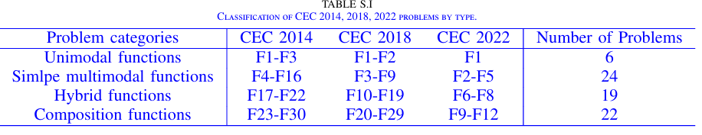

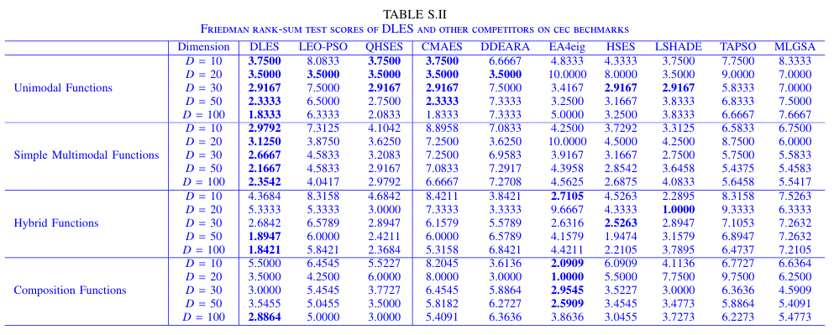
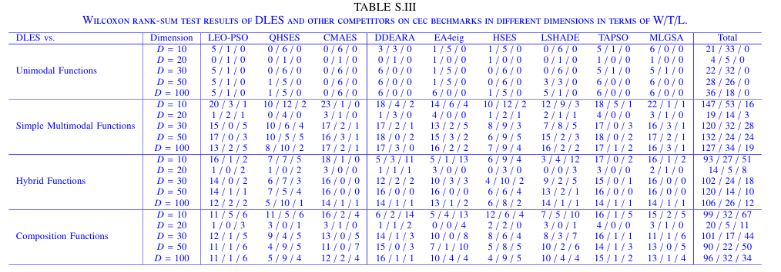
In response to your specific queries, we have addressed the following points:
1)Performance on Multimodal Problems:
Based on Table S.Ⅱ, DLES performs well across various function types and dimensions, consistently achieving top ranks, especially in unimodal and simple multimodal functions. For the specific case of multimodal functions, DLES maintains competitive scores, generally outperforming most other algorithms listed. This suggests that DLES is not a bad predictor for multimodal problems; in fact, it shows strengths across different dimensions.
In Table S.Ⅲ, DLES achieves a notable win/tie/loss (W/T/L) ratio against competing algorithms, especially in higher dimensions (e.g., D = 30, D = 50, and D = 100). The experimental results indicate that as the problem complexity and dimensionality increase, DLES more effectively captures the multimodal characteristics of the problems, thereby avoiding local optima. In the majority of experiments, DLES achieves more wins (W) compared to other methods and maintains a lower failure rate (L), substantiating its robustness and superiority in handling complex optimization problems.
2)Analysis of Method Strengths and Weaknesses:
Strengths: For simple problems, DLES quickly identifies the global optimal solution; for complex problems, DLES leverages its innovative fitness evaluation and search strategies to exhibit stronger optimization capabilities in high-dimensional and complex landscapes.
Weaknesses: While DLES generally performs well, it may not hold a significant advantage in certain specific scenarios, such as extremely low-dimensional simple multimodal problems, where algorithms specifically tailored to these problems may perform better.
Overall, DLES performs well on most problems, only lagging the best algorithms on some specific problems. It also demonstrates excellent performance on multi-peak problems. We hope this effectively addresses your review comments and look forward to your further feedback.

Comment 10: Is there any comparison with the basic algorithm in the sampling or exploration phase of this experiment? How well does it work without the network? How much of an impact does the network have on the improvement of the results?
Response: Thank you for your insightful comments and questions regarding the comparison of our proposed method with the basic algorithm and the impact of the network on the experimental results. We have addressed your concerns as follows:
Comparison with Basic Algorithm: In our experiment, we included the performance of a basic algorithm, referred to as "No-Net," as a baseline to evaluate the effectiveness of incorporating networks. The "No-Net" results provide a direct comparison to understand the improvement offered by our network-based approach. As shown in the Supplementary File Table’s S. IV, the basic algorithm's performance was evaluated across various functions and dimensions. This comparison allows us to quantify the impact of using a network in our framework.
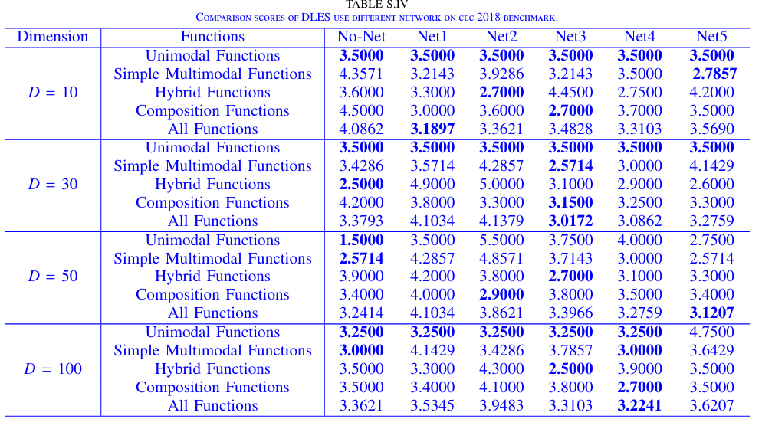
The impact of the network on the results is evident from the comparative analysis in Table S. IV. The performance of various networks (Net1 to Net5) is shown against the basic algorithm ("No-Net"). At D = 30, for Simple Multimodal Functions, Net3 achieved the best score of 2.5714, which is a significant improvement compared to the basic algorithm's score of 3.4286. For Hybrid Functions at D = 50, Net3 outperformed the basic algorithm, achieving a score of 2.7000 versus 3.9000. These improvements demonstrate that integrating networks enhances the algorithm's ability to handle complex functions and higher dimensions effectively. The variability in performance across different networks also indicates that specific network architectures can lead to better results, thereby highlighting the importance of selecting and optimizing the network appropriately.
In summary, our results show that the network-based approach generally outperforms the basic algorithm across different dimensions and functions. The inclusion of networks significantly impacts the results by improving performance in various scenarios, as evidenced by the scores presented in the table. We appreciate the opportunity to clarify these points and hope that this response addresses your concerns comprehensively.

Comment 11: It is recommended that this article provides a graphical representation of the relationship between path, solution space, neural network, fitness, and sampling points.
Response: Thank you very much for your insightful feedback on our manuscript. Based on your recommendation, we have now made the following modifications and additions to better illustrate the relationship between the path, solution space, neural network, fitness, and sampling points.
To provide a clearer understanding of the process and advantages of our proposed DLES algorithm in reconstructing the solution space, we have added a two-dimensional visualization of the algorithm's exploration on the CEC2018 F27 benchmark function. Fig. 4 demonstrates the sampling process of the algorithm as it navigates through the solution space. The sampling path is visualized with green arrows connecting consecutive sampling points, highlighting the sequential nature of the exploration. A pink curve is also included, representing the exploration path reconstructed by the neural network based on the historical sampling points. This curve illustrates how the neural network utilizes past sampling data to form a model of the solution space. This addition is described in Section IV-G
We hope these additions sufficiently address your feedback by providing a comprehensive and intuitive graphical representation of the DLES algorithm's exploration process. The figure and accompanying explanations are intended to clearly depict the interplay between various components, showcasing how our approach effectively reconstructs the solution space to overcome local optima and find the global optimum.

Comment 12: Abbreviations are not recommended for subheadings.
Response: Thank you for your suggestion. We have revised the subheadings for Sections Ⅲ-B and Ⅳ-C to avoid the use of abbreviations. These changes will help ensure clarity and maintain consistency with the context.

Reviewer: 3
The paper proposes DLES, with the main benefit of discovering high-quality areas overlooked by an ES due to insufficient exploration. The paper is well written, however there are a lot of points that should be clarified.
Response: Thank you very much for your thoughtful feedback and positive comments on our manuscript. We greatly appreciate your recognition of the potential of our work and your constructive suggestions for improvement. We understand that there are several points that need further clarification, and we will carefully address each of these in our revisions to enhance the clarity and overall quality of the paper. Thank you again for your valuable input and for helping us improve our work. We look forward to any additional insights you may have.

Comment 1: Page 5, lines 26-28, "DLES records information of the current ..." should be better explained.
Response: Thank you for pointing out the need for further clarification. We have revised the original text to provide a more detailed explanation as follows:
“To enhance the efficiency and effectiveness of network reconstruction, DLES records the information of the current best individual ($y_{best}$) and its corresponding fitness value ($f_{best}$)upon detecting a decrease in fitness. This means that the algorithm updates its records only when a superior solution is identified compared to the previous best. By doing so, DLES ensures that it consistently retains the most optimal solution encountered throughout the search process.”
This addition clarifies the process and enhances the understanding of how DLES maintains and utilizes the best solutions. Thank you for your comment again.

Comment 2: Did you test with other functions different than "tanh"?
Response: Thank you for your comprehensive and insightful evaluation. In addition to using the tanh activation function, we also tested other activation functions, such as sigmoid, ReLU, etc. However, these alternatives performed poorly in our experiments, with the model often failing to converge effectively. We have now added the explanatory content of activation functions in Section III of Supplementary File.
Our preliminary analysis suggests that the performance issues with these functions may be related to the specific characteristics of the problems we are addressing. The test functions used in our experiments have a problem range of [-100, 100] and are centered around intervals like [-5, 5]. For ReLU, which activates only positive inputs, there is a risk of neurons becoming inactive for negative values, a phenomenon known as "neuron death." This can significantly hinder the network’s learning ability and convergence. On the other hand, sigmoid maps values to the range [0, 1], which introduces data skewing during the mapping process. This skewing can lead to issues such as vanishing gradients, further complicating the training process.
In contrast, Tanh activation function, which outputs values in the range [-1, 1], is well-suited for handling centered data. It maintains a balanced output range around zero, which helps in capturing the nuances of the data and improves the learning efficiency. This is why we selected Tanh as the activation function for our experiments.

Comment 3: There are a lot of landscape analysis studies that have shown that CEC 2014, CEC 2018, and CEC 2022 cover similar landscapes. Even more, adding or removing one function can completely change your ranking results with Freidman. What I recommend is to select a representative benchmark dataset diverse in landscape characteristics and then do the ranking approach. Your results are affected by the selection of the benchmark suite. Please also include BBOB, for which CMAES has a great performance.
Response: Thank you for your valuable suggestion. We acknowledge that the problems covered by CEC 2014, 2018, and 2022 indeed exhibit significant similarities, which can influence the overall benchmarking results. Following your suggestion, we have now expanded our experiments to include the BBOB dataset, which offers a diverse set of landscape characteristics. We compared our proposed DLES with other competitive algorithms, including CMAES, a-CMAES, sc-CMAES, HSES, and E-WOA. The experimental results are presented in Table II in Section Ⅳ-C.
Overall, DLES still demonstrates excellent performance across the BBOB dataset, achieving consistently strong rankings on nearly all tested functions. A more detailed analysis of the performance of DLES, compared to other algorithms, is provided in the Supplementary File.

Comment 4: Recording 0 for results less than 10^-8 is ok, but there are practical significance approaches that can handle this, so it is better to use them.
Response: Thank you for your perceptive remarks and recommendations. Setting values less than 10^-8 to zero is a requirement specified in the official CEC testing guidelines, which is why we adhered to this approach for our experiments on the CEC test sets. However, we acknowledge that using alternative methods could provide a more nuanced comparison of algorithm performance.
According to your suggestion, for the experiments conducted on the BBOB test set, we have retained the full precision of the values without truncating to zero. Additionally, we utilized logarithmic scaling in our plots to better visualize these small values, thereby offering a more accurate and meaningful representation of the results. This approach allows for a clearer and more practical comparison of the algorithms' performance across different problem landscapes.
We have added the explanation in Section IV-A.

Comment 5: Wilcoxon rank sum test is doing only pairwise comparison.
Response: Thank you very much for your comment. I appreciate your careful review and helpful comments, and you are correct that the Wilcoxon rank sum test performs only pairwise comparisons. In our manuscript, the comparison results presented are indeed based on pairwise comparisons between DLES and other competing algorithms. The intention is to highlight the performance differences between DLES and the benchmark algorithms across various problem dimensions. The "total" column in the table is included to provide a more comprehensive and intuitive overview of DLES's overall performance across all pairwise comparisons. This summary helps to convey the general trend of DLES's effectiveness relative to the other algorithms. Besides, for multiple-wise comparison, we use the Friedman test to analyze the differences among algorithms.

Comment 6: The Friedman test uses a fractional ranking scheme to rank the results. Please elaborate on how many different seeds you use running DLES on each function, and how you aggregated the performance before ranking, since this has a huge effect on the results.
Response: Thank you for your valuable comments and for raising this important point. Each experiment for each function allocates a distinct random seed. In our experiments, we used 51 different random seeds to run DLES on each function. This ensures that the results are not biased by a specific random initialization and allows for a more comprehensive assessment of the algorithm's performance. The use of multiple seeds helps capture the variability in performance and provides a more reliable average when evaluating and comparing the algorithms.
For the Friedman test, we used the mean performance of these 51 runs for each algorithm as the basis for ranking. This approach provides a stable representation of the algorithm's performance by minimizing the impact of any outliers or variability that might occur in individual runs. We have now added the explanation in Section IV-A.
We appreciate your attention to this detail, as the method of aggregation can indeed significantly influence the results. By using the mean of 51 independent runs, we aimed to present a fair and comprehensive comparison of the algorithms' performances.
We hope this clarification addresses your concern, and we appreciate your careful consideration of our methodology. If you have any further questions or suggestions, we would be happy to discuss them.

Comment 7: Reporting the average rankings does not provide any explanations of the results, even more, the rankings can be different but from a statistical point of view it cannot be counted as a difference (doing a posthoc test).
Response: Thank you for your constructive criticism and suggestions. We have now included a post-hoc analysis on BBOB in Section IV of Supplementary File. Specifically, we used Empirical Cumulative Distribution Functions (ECDFs) to analyze the experimental results on the BBOB test set. The overview results are shown in Fig. S.III
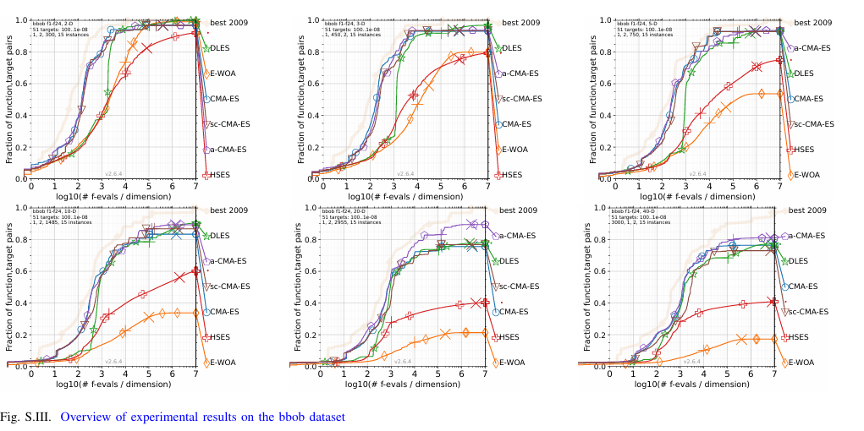
The post-hoc analysis using ECDFs offers a more nuanced view of DLES's effectiveness compared to average rankings. This approach reveals how DLES excels across various dimensions, demonstrating superior performance and faster convergence, particularly in 2, 3, and 10-dimensional cases. However, it also highlights that DLES shows slightly less effectiveness on specific problems compared to the advanced variant of CMA-ES (a-CMAES), although it still surpasses the original CMA-ES and sc-CMAES. This detailed statistical assessment enriches our understanding of DLES’s performance, affirming its robustness while recognizing the subtle performance variations across different scenarios.

Comment 8: You presented only general results, and it seems like one more algorithm for optimization no matter how it works, without explanations. I would appreciate seeing differences of rankings across different problems and also linked to their problem landscape characteristics.
Response: Thank you for your perceptive remarks and recommendations. To address your concerns, we have now added additional experimental results to provide a clearer analysis of DLES's performance across different problem types in Section II of Supplementary File.
In the CEC series, we have categorized the 71 benchmark problems into 4 types, as outlined in Table S.I, following the guidelines provided in the CEC official manual. For the BBOB benchmark, we have classified the problems into 5 categories, as specified in the BBOB official documentation.
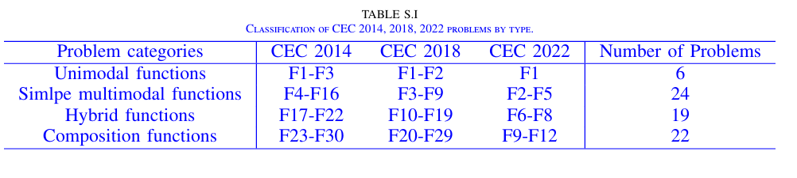
The detailed results are shown in Table S. II, the DLES algorithm demonstrates exceptional performance across various EC benchmark functions, particularly excelling in unimodal and simple multimodal functions. In unimodal function tests, DLES performs remarkably well across multiple dimensions, notably showing strong optimization capabilities at D = 10 and 20. For simple multimodal functions, DLES exhibits robust performance across all tested dimensions, with particularly impressive results in lower-dimensional problems. In the hybrid functions category, DLES also achieves excellent performance in moderate dimensions, such as D = 30 and 50. However, in the composition functions category, DLES shows relatively weaker performance, particularly in lower-dimensional problems. Overall, DLES reveals strong optimization capabilities across various function types, with only marginally lower performance in specific functions.
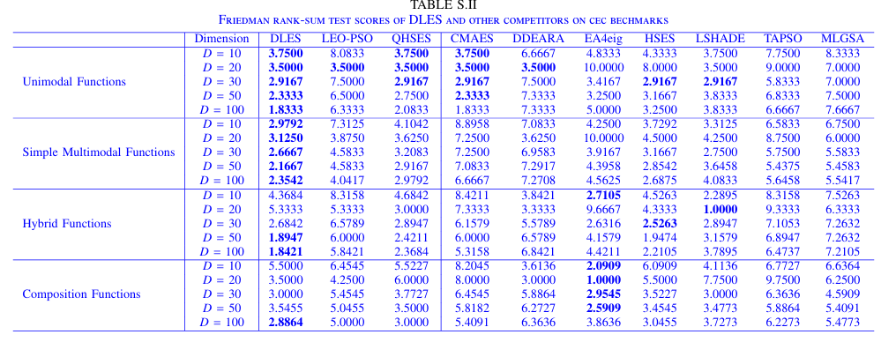
Besides, we provided additional analysis, including ECDFs for different problem types on the BBOB test set, with an overview of experimental results in D = 10 shown in Fig. S.IV. The results indicate that DLES maintains strong performance across all five problem categories. Notably, DLES achieves the best performance on Separable Functions and Multi-modal Functions with Weak Global Structure, surpassing CMAES and its optimized versions. In terms of convergence speed, DLES is slightly slower than A-CMAES, the fastest among the algorithms tested, but the difference is minimal. This demonstrates DLES's competitive edge in maintaining high solution quality while achieving near-optimal convergence efficiency across various problem types. The detailed introduction is described in Section IV of Supplementary File.
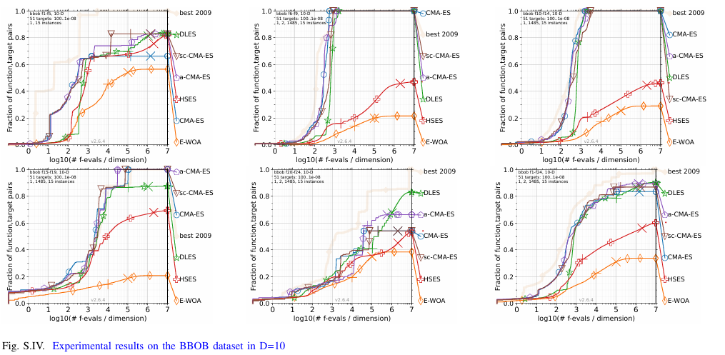
Comment 9: Add results as Fig3 for all problems (supplementary materials) or some online repo. In addition, you can use a convergence statistical test to test the outcomes.
Response: Thank you very much for your valuable suggestion. We have now included all results in Section V of Supplementary File. This section presents ECDF plots for DLES and five other comparison algorithms across all dimensions on the BBOB test set, average convergence curves and box plots for DLES compared to nine other algorithms across all problems from CEC 2018, and the mean and variance of the final results for DLES and the nine comparison algorithms across all dimensions for the CEC series problems.

Comment 10: In general, one more algorithm for which we are just focused on increasing performance on several benchmarks, without knowing the real benefits and where it can provide the best results.
Response: Your thoughtful analysis is highly valued. To address your concerns and better illustrate the specific advantages of the DLES algorithm, we have now conducted a focused analysis in Section IV of Supplementary File using three representative ECDF plots: F4 Büche-Rastrigin Function, F22 Gallagher's Gaussian 21-hi Peaks Function, and F23 Katsuura Function. These benchmarks are known for their highly multimodal nature and complex search spaces, characterized by numerous local optima, asymmetry, and non-linear search landscapes, which challenge an algorithm’s robustness and adaptability.
As depicted in Fig. S.V, DLES demonstrates significant superiority in solving these complex, multimodal, and high-dimensional problems. The results highlight DLES’s strong global search capabilities, enabling it to effectively avoid local optima while progressing toward the global optimum. Moreover, DLES shows excellent adaptability and robustness in managing irregular search spaces, outperforming other algorithms in terms of both convergence speed and accuracy. These findings underscore DLES's efficacy in tackling challenging optimization tasks, validating its specific benefits in scenarios where complex landscape characteristics are present.
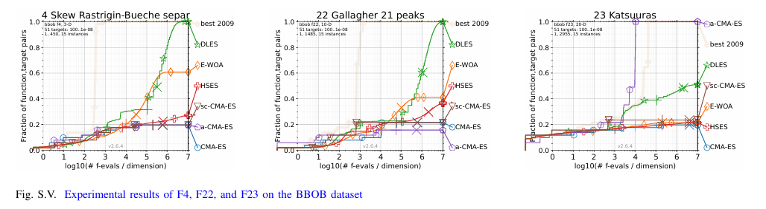
Importantly, our approach differs from traditional evolutionary algorithms, which primarily rely on current population information to generate offspring. DLES, on the other hand, gathers critical insights from the entire search process by fitting exploration paths. While using neural networks to model solution spaces is not a new concept, most previous approaches perform poorly because they attempt to fit the entire solution space, resulting in excessive network load. By focusing solely on fitting the exploration paths, we significantly reduce the network’s burden, allowing even relatively simple architectures to handle complex tasks.
The introduction of neural networks, with their powerful nonlinear fitting capabilities, enables DLES to combine the strengths of both network-based and algorithm-based methods. This hybrid approach is more than just improving benchmark performance; it demonstrates the potential to solve complex, high-dimensional problems more effectively, highlighting their value in optimization tasks.
We have now included additional explanations in Section Ⅴ.

The authors would like to thank all editors and reviewers for their insightful and constructive comments that have greatly helped us improve our study and manuscript.

